**Aim: Introduction to 8086 Micro Processor and simulation tools.**

**Theory:**

8086 Microprocessor is an enhanced version of 8085Microprocessor that was designed by Intel in 1976. It is a 16-bit Microprocessor having 20 address lines and16 data lines that provides up to 1MB storage. It consists of powerful instruction set, which provides operations like multiplication and division easily.

8086 supports two modes of operation, i.e. Maximum mode and Minimum mode. Maximum mode is suitable for system having multiple processors and Minimum mode is suitable for system having a single processor.

## Features of 8086

The most prominent features of a 8086 microprocessor are as follows −

* It has an instruction queue, which is capable of storing six instruction bytes from the memory resulting in faster processing.
* It was the first 16-bit processor having 16-bit ALU, 16-bit registers, internal data bus, and 16-bit external data bus resulting in faster processing.
* It is available in 3 versions based on the frequency of operation
  + 5MHz, 8MHz, 10 MHz
* It uses two stages of pipelining, i.e. Fetch Stage and Execute Stage, which improves performance.
* Fetch stage can prefetch up to 6 bytes of instructions and stores them in the queue.
* Execute stage executes these instructions.
* It has 256 vectored interrupts.
* It consists of 29,000 transistors.
* **Difference between 8085 and 8086 Microprocessor**

|  |  |
| --- | --- |
| **8085 Microprocessor** | **8086 Microprocessor** |
| It is an 8-bit microprocessor. | It is a 16-bit microprocessor. |
| It has a 16-bit address line. | It has a 20-bit address line. |
| It has a 8-bit data bus. | It has a 16-bit data bus. |
| The memory capacity is 64 KB. | The memory capacity is 1 MB. |
| The Clock speed of this microprocessor is 3 MHz. | The Clock speed of this microprocessor varies between 5, 8 and 10 MHz for different versions. |
| It has five flags. | It has nine flags. |
| 8085 microprocessor does not support memory segmentation. | 8086 microprocessor supports memory segmentation. |
| It does not support pipelining. | It supports pipelining. |
| It is accumulator based processor. | It is general purpose register based processor. |
| It has no minimum or maximum mode. | It has minimum and maximum modes. |
| In 8085, only one processor is used. | In 8086, more than one processor is used. An additional external processor can also be employed. |
| It contains less number of transistors compare to 8086 microprocessor. It contains about 6500 transistor. | It contains more number of transistors compare to 8085 microprocessor. It contains about 29000 in size. |
| The cost of 8085 is low. | The cost of 8086 is high. |

* **8086 pins configuration**

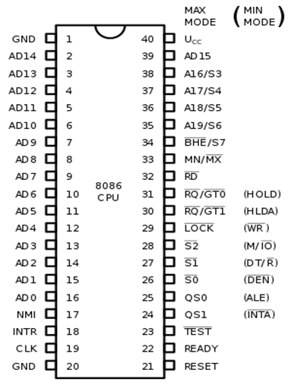

The description of the pins of 8086 is as follows:

**AD0-AD15 (Address Data Bus):** Bidirectional address/data lines. These are low order address bus. They are multiplexed with data.

When these lines are used to transmit memory address, the symbol A is used instead of AD, for example, A0- A15.

**A16 - A19 (Output):** High order address lines. These are multiplexed with status signals.

**A16/S3, A17/S4:** A16 and A17 are multiplexed with segment identifier signals S3 and S4.

**A18/S5:** A18 is multiplexed with interrupt status S5.

**A19/S6:** A19 is multiplexed with status signal S6.

**BHE/S7 (Output):** Bus High Enable/Status. During T1, it is low. It enables the data onto the most significant half of data bus, D8-D15. 8-bit device connected to upper half of the data bus use BHE signal. It is multiplexed with status signal S7. S7 signal is available during T3 and T4.

**RD (Read):** For read operation. It is an output signal. It is active when LOW.

**Ready (Input):** The addressed memory or I/O sends acknowledgment through this pin. When HIGH, it denotes that the peripheral is ready to transfer data.

**RESET (Input):** System reset. The signal is active HIGH.

**CLK (input):** Clock 5, 8 or 10 MHz.

**INTR:** Interrupt Request.

**NMI (Input):** Non-maskable interrupt request.

**TEST (Input):** Wait for test control. When LOW the microprocessor continues execution otherwise waits.

**VCC:** Power supply +5V dc.

**GND:** Ground.

## 

## Process to install Emulator:

## <https://emu8086.en.lo4d.com/windows>

## 

## 

## Sample program for the addition of two numbers

## Step:1 – Write the code of program.

## 

## Step:2 – Save the program.

## 

## Step:3 - Compute and save the Program.

## 

## Step:4 – Update memory location and provide the data.

## 

## 

## Step:5 – Run the program and check the output.

## 

**Conclusion:**